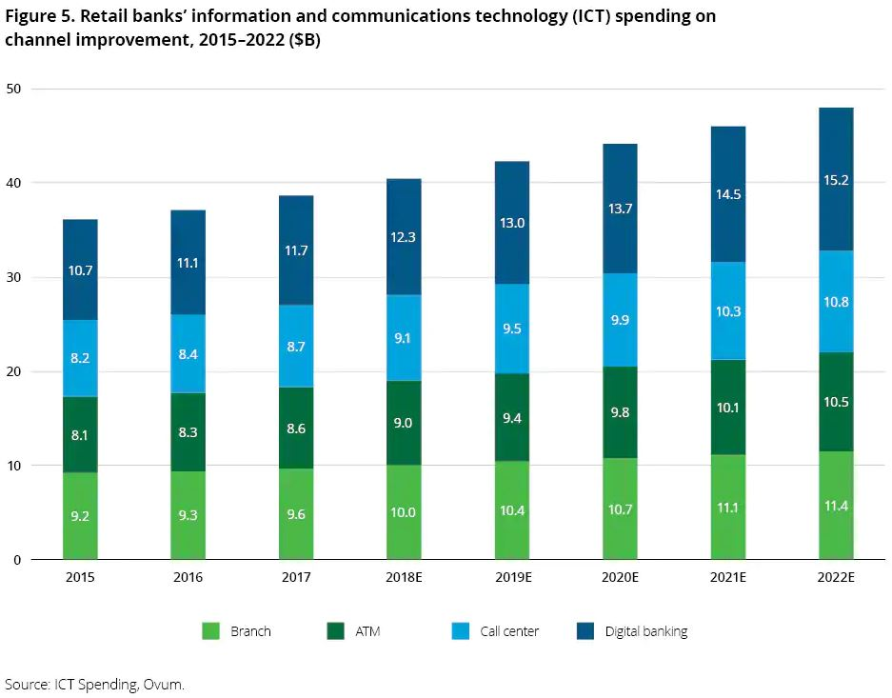

Please write a brief paragraph in which you analyze some of the trends shown in this figure. Remember to reference the figure, and use signaling words which are appropriate for the type of data displayed.